Business Planning, Governance, Risk Management, and Compliance in Saudi Electricity Company
Student's Name
Institution of Affiliation
Date

Table of Contents
Executive Summary 3
Introduction 4
Overview of Saudi Electricity Company 4
Literature Review 6
Analysis of Model, Technology 8
Process 1: Governance, Risk Management and Compliance (GRC) 8
Process Introduction 8
Technology in Use 9
System Architecture 12
Process Explanation 13
The process Workflow 15
Process Analysis 16
Process 2: Business Planning and Consolidation 17
Process Introduction 18
Technology in Use 20
System Architecture 20
System Explanation 21
The Process Workflow 23
Process Analysis 24
Recommendations 24
Conclusion 25

Executive Summary
This report provides an in-depth analysis of the business processes applied by the Saudi Electricity Company. The Saudi Electricity Company is Saudi Arabia's largest utility company responsible for the generation, transmission, and distribution of electric energy. The report focuses on two business processes implemented by Saudi Electricity Company to achieve its goals and contributes to its success. The selected processes are Governance, risk management and compliance (GRC), and Business planning and consolidation (BPC). The report provides a comprehensive analysis of each process, including its technology use, architecture, process explanation, workflow, and process analysis, to gain a better understanding of the processes. Additionally, the report presents the recommendations that would help Saudi Electricity Company better enhance the functionality of these processes and enhance the achievement of the desired goal.

Introduction
Business processes are critical assets for any company or organization. They guide the organization towards achieving its objectives. Business processes are specific, purposeful, and have consistent outcomes. While they are important assets to any organization and may occur at all levels, sometimes they may not be visible to the organization's users or customers. The business environment is dynamic, meaning it undergoes constant changes; when it does organization must also undergo transformation to keep abreast with these changes or risk being obsolete. As organizations undergo these changes to fit into the evolving business environment, it is the business processes that are affected, which in turn, impact process enablers. This report provides an in-depth analysis of two processes implemented by the Saudi Electricity Company. These two processes are Governance, risk management, and compliance, and business planning and consolidation. The report mainly focuses on the technologies Saudi Electricity Company uses to enhance these processes to achieve organizational success.

Overview of Saudi Electricity Company
Saudi Electricity Company (SEC) is a publicly listed Saudi Arabian power company that generates, transmits, and distributes electric power in Saudi Arabia. The company has its headquarters in Riyadh, Saudi Arabia. Saudi Electricity Company was formed in 2000 through an amalgamation of local electricity companies in Saudi Arabia to form one joint-stock company. 81.22% of the company is owned by the government of the kingdom of Saudi Arabia("Company Information," 2021). The company is the Gulf region's largest utility by market values enjoying dominance in electric energy generation, transmission, and distribution across Saudi Arabia through its45 power generation plants. SEC manages more than 37000 megawatts of electric energy across its 45 power plants serving agricultural, commercial, governmental, industrial, and industrial consumers. The company has more than 33000 employees who work in various company firms and subsidiary companies. SEC generates more than $17 billion in annual sales, making it one of the largest companies in the Kingdom of Saudi Arabia and the world("Company Information," 2021).
The Saudi Electricity Company's mission is to reliably provide electric energy to the entire Kingdom of Saudi Arabia while optimizing the available resources. The company aims to optimize the power generation mix to meet the growing demand and lowering the cost of electrical power production, and, as a result, achieving the company's objectives. The Electricity and Cogeneration Regulatory Authority (ECRA) announced in 2009 its intention to break the company into separate generation, distribution and transmission companies to encourage competition in the energy sector. The split led to the establishment of the National Grid SA in 2012, a transmission company operating on the national grid. The split of SEC to separate companies would be available to foreign investment, therefore, opening them up to new markets and contributing to economic growth. SEC continues to maintain dominance and monopoly in power generation, transmission, and distribution through separately established companies such as the National Grid Company (Alkedmn& Eckler, 2019).
The Saudi Electricity Company regards power generation as its principal activity and the main pillar for its business. SEC's separate companies are responsible forthe transmission and distribution of the energy to the end-users. They are also responsible for services such as connecting transmission lines from substations to local substations and end-users, billing, metering, electrical service connections, payment collections,

Literature Review
The business environment's intensity calls for companies and organizations to take a different approach to risk management. Today's business environment presents unparalleled business and regulatory impediments coupled with disruptive technologies. Companies require innovative and proactive GRC strategies to meet their stakeholder's expectations and get hold of available competitive opportunities. Recent technological advancements have significantly affected all aspects of life, and businesses are no exception. Wiedenhoft, Luciano, and Magnagnagno (2017) assert that business is at the forefront of experiencing the influence of technology. In today's business environment, technology plays a more critical role in creating, shaping, and influencing new business models compared to traditionally when it was just a facilitator for implementing business models. Besides influencing the core business process of a company, technology also facilitates functions such as Governance, risk management, and compliance to using to enhance their contribution and value proposition (Miller, 2017).
Governance, risk management, and compliance are essential aspects in organizations that help achieve their business goals and objectives. Governance involves a combination of actions and processes established, approved, and implemented by the company's board of directors and facilitated through the company's structure to drive it towards achieving its goals. Risk management encompasses identifying, assessing, and managing risks impeding the company's achievement of its business goals and objectives. The compliance aspects ensure that the company has internal controls and processes to meet regulations, standards and was by regulators, government bodies, policies, and industry mandates. Murray and Ward (2018) assert that the effectiveness of the Governance, risk management, and compliance (GRC) function is ensuring companies meet their business objectives. Technology enhances their ability to achieve these objectives in a compliant and well-managed environment.
Saudi Electricity Company enjoys a monopoly of the gulf region market with a peak load of over 60000 megawatts. Demand for electric power energy continues to increase and is expected to continue rising into the future due to a growing population, expanding industrial base, and increasing per capita consumption. The Saudi Electricity Company's primary objective is the generation and provision of safe, cost-efficient, and reliable electric power to end-users. This aligns with the Kingdom of Saudi Arabia's government policy of developing the electricity sector of the country. SEC's integration of technology into its operations propels the company's growth. All management levels are compelled to act in line with principles of Governance, risk, and compliance. However, the risk of certain departments and managerial levels pursuing their interests or committing errors because of communication misunderstandings becomes greater with the increase in the company size. Bigger companies such as SEC run this risk; therefore, management addresses their issues through an internal audit (Raiborn et al., 2017). The Saudi Electricity Company's use of SMART GRC enables them to monitor their action and process and ensure they are compliant, and work towards achieving its overall goal.
In business, one can be hard-pressed to find a solution that addresses challenges for all organizations. An integrated GRC and other software tools can be important in company processes and activities that require significant organizational input. The Saudi Electricity Company's implementation of the integrated SMART GRC helps it streamline its business operations and enhance its function. The use of multiple fragmented systems can cause confusion; therefore, an integrated SMART GRC reduces unnecessary actions and helps the company focus on the processes that lead to the achievement of the overall goal. SEC's use of a single integrated system has improved the company's organization as it has a single process that serves as a central reference point for its business operations. Additionally, SMART GRC allows the company to cut down on multiple software use as it uses a single integrated and comprehensive solution. This integrative approach is favorable to the company as it is straightforward and distinct.

Analysis of Model, Technology

Process 1: Governance, Risk Management and Compliance (GRC)
Saudi Electricity Company's approach to Governance, risk management, and compliance (GRC) has consistently grown to be more strong and comprehensive. The company is committed to adhering to local regulatory guidelines and international industry standards. Saudi Electricity Company's corporate governance framework hinges on the provisions of regulations provided by the companies law, the Electricity and Cogeneration Regulatory Authority (ECRA) and the Capital Market Authority of Saudi Arabia, and Saudi Electricity Company's Articles of Association. The company's vision of serving its customers and country through the provision of power services guides it in strengthening its governance, risk management, and compliance. Under SEC's governance, risk, and compliance framework, the company's board of directors is charged with creating effective governance, risk management, and compliance system (Harper, 2020). The company's internal control measures and risk management efforts that focus on protecting shareholders' and other stakeholders' rights are essential to GRC. The company's corporate governance entails strategic direction and oversight components. The strategic direction component determines the company's business objective, model, and risk management methodology, while the oversight component conducts both internal and external assurance and risk management activities.

Process Introduction
Business processes are structured tasks or activities performed by an organization to achieve its goal of providing a product or service to its customers. The Governance, risk management, and compliance process is an organized approach to aligning the company's business model and objectives at the same time managing risk effectively and complying with regulatory standards and requirements. Governance involves procedures and activities approved and undertaken by the executive to support the company's business goals and objectives. Governance includes processes such as management of the company's IT operations and ensuring they align with the business goals. Risk management involves identifying and addressing risks associated with the company's activities and could be an impediment to achieving its goals. As Saudi Electricity Company has embraced and integrated technology in its activities and functions, cyber security is a significant risk; therefore, having a comprehensive IT risk management methodology is an essential aspect of the company's enterprise risk management function (McShane, 2018). Compliance entails ensuring the company's activities and operations fall within the regulations and mandated laws affecting systems. Meeting compliance entails applying and auditing the controls to ensuring their functionality is as intended. Saudi Electricity Company relies on its GRC framework for the strategic direction in growth and enhancing its governance and risk management operations rather than developing a new one from scratch.

Technology in Use
The integration of risk management systems within a company's operational and strategic decision-making process is integral to its success in business. Corporate Governance is a significant aspect of enterprise risk management in the modern business world as logical business practices impact the company's level of security (Ali, 2020). This enables the company to protect the shareholders' as well as stakeholders' rights while creating a clear strategy to drive it to success. Saudi Electricity Company audit committee oversights its financial affairs on behalf of the board for the interest of the company's shareholders. The committee audits a wide range of aspects, including information presented in the company's financial statements to the efficacy of the internal control environment (Gerged&Agwili, 2020). The company relied on an internal customized system to support its audit process and risk management. The company needed a fully integrated system to replace the fragmented internal audit, risk management, and tracking system. The fully integrated system would allow for systematic and progress-driven audit and risk management procedures that would do away with audit errors and inconsistencies (Raiborn et al., 2017).
Saudi Electric Company settled on the SMART GRC suite for audit and assessment issues, risk management tracking, and compliance. SMART GRC tool enables the company to enhance the productivity of its audit team through analysis and unification of audit data from various departments in a fast and efficient manner. SMART GRC suite has automated reporting of compliance and risk management activities as well as documentation.
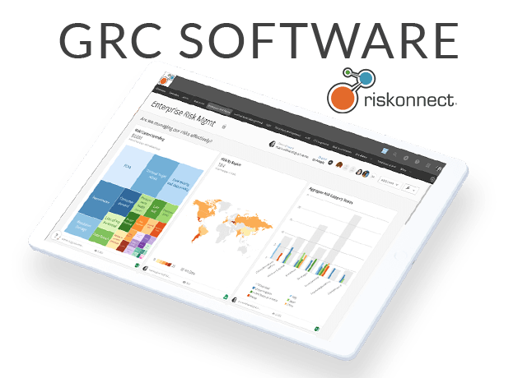
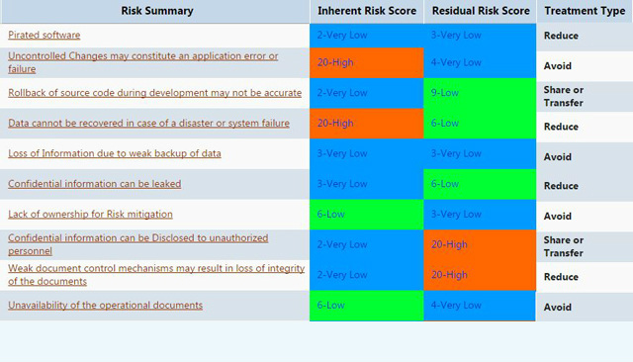

System Architecture
The system architecture describes the behavior and structure of a system. The system architecture for the SMART GRC software tool is presented as follows. It covers Governance, risk management, and compliance.
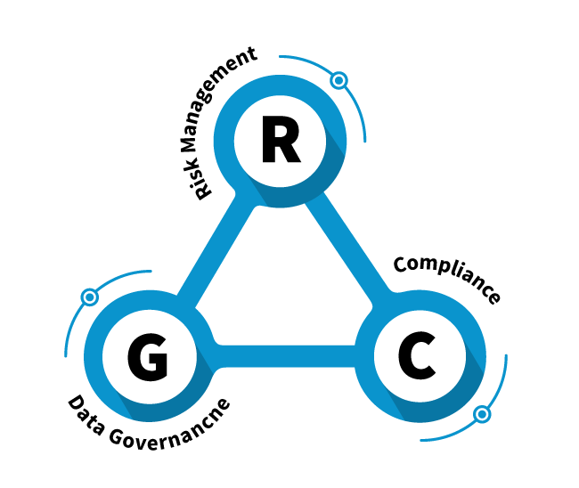
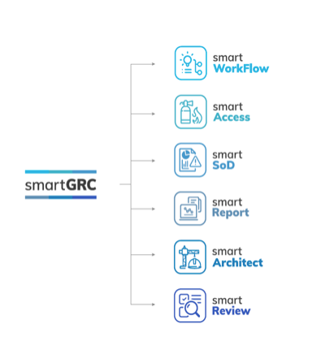
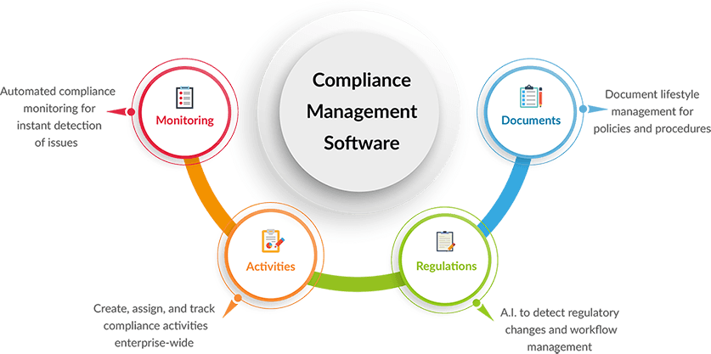

Process Explanation
It is increasingly becoming challenging and expensive for companies to comply with multiple often overlapping regulations, laws, and standards. SMART GRC provides Saudi Electricity Company with an integrated platform with solutions that upholds the company's business and performance objectives while reducing risks. The company's approach to the GRC process is based on the principle of getting their activities and procedures right and maintaining them. SEC GRC framework identifies measurables that focus on the effectiveness of the company's GRC efforts. The framework provides the foundation on which the company can shape or influence its environment. SMART GRC enables SEC to create and coordinate control and policies and align them to internal and regulatory compliance requirements. The software tool is cloud-based and has enabled automation of many of the company's actions and processes therefore increasing its efficiency and minimizing complexity.
The implementation of the integrated SMART GRC in the company has significant benefits, including;
- Automation of documentation as well as compliance and risk management activities, therefore, minimizing the need for spreadsheet or paper to inform users or plan.
- The software tool provides a shared audit Calendar that has significantly reduced time used in the preparation of audits as well as minimized administration budget and work, especially in the generation of audit checklists and reports.
- The software tool provides whole round visibility in the audit metrics and processes that help in better compliance to regulatory requirements and risk management.
- SMART GRC applies a closed-loop system to the audit cycle, especially on record findings, implementation of action plans, and development of recommendations.
- The software tool gives the company the ability to identify issues, perform assessments and manage activities directly through the use of technological devices such as tablets and mobiles.
- It automates actions, progress, and notification to ensure compliance.
- SMART GRC presents a ready-to-use dashboard with custom reports.

The process Workflow
The world is constantly evolving and changing. Things that were thought not to happen have happened, and those that were expected to occur did not. Risk management has become an important aspect in organization operations spanning geographical and corporate boundaries. The purpose of Governance, risk management, and compliance (GRC) is to minimize costs, risks, and the duplication of actions and effort. GRC requires corporations across the board to accomplish results that meet internal processes and guidelines established for the elements of Governance, enterprise risk management, and compliance (Harper, 2020). The SMART GRC suite adopted and implemented by SEC supports management of user access process in business application and systems. SMART GRC enables the company to automate the process of assigning and removal of access. It allows for the collection of data regarding the segregation of duty risks that are associated with the implementation of user requests (Harper, 2020). The segregation of duties risk analysis allows the company to make more accurate, efficient and controlled access decisions about accepted and approved permissions. The integrated SMART GRC is designed to automate complex workflow processes. The software tool allows the company to obtain required by the board on the acceptable levels of segregation of duties risks with access to business processes and applications. The SMART GRC empowers Saudi Electricity Company to;
- Increase control and transparency of the entire business process.
- Full automation of the company's actions and processes.
- Automatically implement requisition in the SAP system.
- Minimize unnecessary iterations.
- Provide support for the company's business process.

Process Analysis
Over the years, there has been an upward trend in companies' automation of their GRC actions and processes through internal customized systems or integrated third-party GRC softwares. GRC takes an organized approach to aligning company processes with its objectives while managing risk and ensuring compliance requirements and standards are met. SEC's implementation of GRC software helps the company automate documentation, compliance activities, and risk management. GRC process is critical in audit, compliance, risk, and policy management. SEC shift towards a more integrated solution encompassing numerous aspects of GRC provides the company's management with the software's significant influence on the company.
As SEC evaluates its data needs and current risk information, the company's executives and management find it beneficial to work IT functions to build and enhance the GRC's support system. The application of the GRC software in the company's information technology governance process ensures management's need for risk management information is included in the company's information management strategy.
Business companies and organizations rely on data to inform their daily decision-making process, therefore, increasing even more, the importance of GRC. GRC affects multiple company decisions; therefore, having a GRC program that is informed by data is critical to connecting and comparing activities occurring within the company. Saudi Electricity Company leverages data analytics that is supported by technology for their GRC, therefore, helping them acquire relevant information to guide their business decision-making without affecting the governance, risk, and compliance standards within the company's operating model. Additionally, data analytics helps the company to allocate resources to important areas in accordance with the GRC requirements better. Automation technologies have enabled SEC, like other organizations, to develop their core GRC requirement in the business process automation plan. This has allowed Saudi Electricity Company to manage its GRC objectives which contributes to the overall GRC framework. Investment in technology in the business process has been associated with improved returns for companies due to flexibility and scalability as technology transforms the business and operating models affecting both the internal and external ecosystem. A company's ability to incorporate and implement these changes to its GRC is crucial for achieving good governance and risk management. GRC programs and practices that are technology-enabled to adapt to these changes faster and better, therefore, keeping the company well-governed, with better risk management strategies, and compliant with the regulations and standards while achieving better returns.
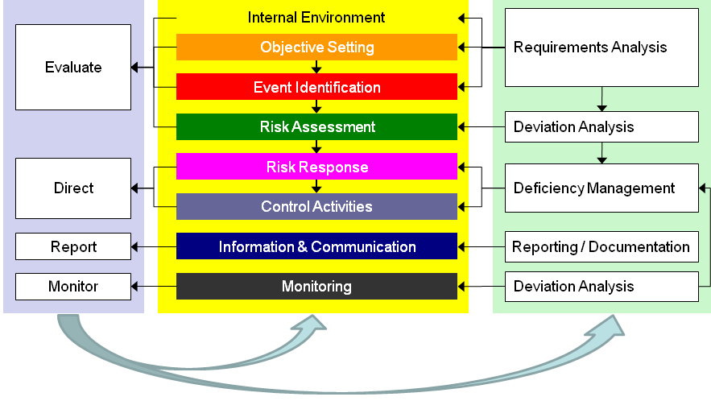

Process 2: Business Planning and Consolidation
SAP business planning and consolidation (BPC) is a module that supports an organization's financial and operational activities. SAP BPC provides planning, forecasting, budgeting, and financial, management, and legal consolidations. Additionally, it offers a single view of operational and financial data and a merged solution backing performance management processes, for instance, forecasts, adjusting the plan, closing cycles, and enhancing the budgeting process. The tools streamline planning, budgeting, forecasting, and consolidation, therefore, improving the organization's decision-making process. SAP BPC offers a robust and highly scalable database integrated with logic capabilities and business process to create an Enterprise Performance Management (EPM). SAP BPC encompasses business process flows that organizations can use as formal workflows for operational and financial processes.

Process Introduction
SAP Business Planning and Consolidation (SAP BPC) is a tool providing organizations with planning, budgeting, forecasting, and consolidating capabilities. The software tool supports an organization's financial and operational activities. It enables organizations to address the challenging and long process of data collection and validation across comprehensive and complex systems. SAP BPC is used by organizations to enhance financial planning, budgeting, financial reporting, and consolidation while minimizing compliance risk (Huang et al., 2018). Business planning and consolidation address its core capabilities of planning, budgeting, forecasting, and consolidation in the following ways.
- Planning.
Planning entails making a long rage organization or arrangement of activities lasting a certain period of time to achieve the desired goal. Planning can be done for an activity taking weeks, months, or even years. The process of planning entails creating a plan that will guide the organization's actions to achieve its long-term goals. Different organizations use various models with strategic planning covering a certain period into the future. The planning process incorporates both financial and non-financial information to create a complete view of the organization. SAP BPC provides the organization with a platform to combine business planning, financial and operational processes, and connecting strategy to achieve their objectives.
- Budgeting
Budgeting entails creating an organizational plan of spending money. Budgeting enables organizations to determine the availability of sufficient resources to perform their functions. Organization budgeting begins with targets or predefined assumptions, while others start with detailed inputs from participants in the organization. Various organizations develop their budget through a combination of methods, including bottom-up or top-down assumptions. Saudi Electricity Company, however, develops its budget through a collaborative and iterative process.
- Forecasting
This is a process of making business predictions based on present and past data available. With the changing business environment, many organizations are abandoning the traditional budgeting process in favor of forecasting as more data is becoming available to organizations. SAP BPC merges the actual and forecast periods to create one version, therefore facilitation a more efficient analysis and reporting. BPC allows SEC to predict, estimate and process its future financial performance.
- Consolidation
In business, consolidation encompasses integrating or merging various business processes to make an organization stronger. BPC has a build-in consolidation capabilities functionality incorporating legal and management processes (Huang et al., 2018). The use of BPC in the Saudi Electricity Company allows its customers to use various integration options, for instance, real-time consolidation with the ERP solution.

Technology in Use
Saudi Electricity Company is without a doubt the largest power utility company in Saudi Arabia, and like many other organizations, it involves numerous operational processes as it provides energy to its customers. Just like many organizations, SEC faces significant challenges that affect its ability to perform its role and achieve its goal. The advent of technology and the changing business environment have resulted in the company's integration of technology in its operational process. Saudi Electricity Company has implemented the use of SAP BPC software as a significant solution of EPM suite. The software tools help the company to exploit the value of their existing data sets. BPC provides the company access to real-time and dependable corporate data in addition to streamlining its financial planning and consolidation processes. BPC tools let the company align its operational plans with corporate initiatives, metrics, and goals using the strategy management application. Saudi Electricity Company uses the tool to plan, understand the risk factors facing the company and the available financial resources budgeted for its operation (Gerged&Agwili, 2020). BPC's comprehensive approach allows the company to effectively manage risk, optimize business profitability and ensure compliance while maximizing corporate processes, systems, and people. This technology automates the company's manual processes allowing it to improve compliance, short budget cycles, and enhance financial close. SAP BPC provides a unified, comprehensive solution to planning, forecasting, budgeting, and consolidation. This software is maintained by the SEC's financial manager.

System Architecture
SAP BPC uses various script logics and business rules to perform its functionalities. The core components of the BPC system architecture are presented as follows.
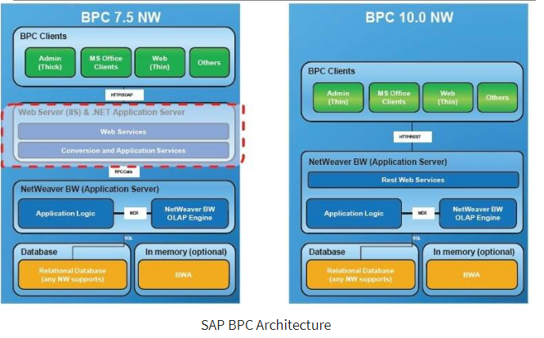

System Explanation
SAP BPC software tool connects SAP and non-SAP data with integrated functionalities to enhance the company's close. BPC enables fast and reliable financial close, lowers auditing costs and compliance, therefore, enhancing stakeholder confidence. Additionally, it enhances the company's data through its central data repository. BPC has consolidation capability functionalities that support the company's legal, statutory, and management consolidations (La Rosa et al., 2013). The tool complies with financial reporting standards and requirements, including GAAP.
SAP business planning and consolidation offer a comprehensive database with strong performance through an integrated ERP system, SAP S/4HANA. The software tools combine logistical capabilities and business process automation.SAP BPC is highly scalable therefore resulting in a customized EPM solution. Saudi Electricity Company has integrated this software tool into its planning and operation process, therefore, allowing for the incorporation of financial operations, overarching strategy, and performance process. In Saudi Electricity Company, SAP BPC offers workflow functionality for the company's financial and operational processes through business process flows. The company uses the software tool to organize budgeting, corporate planning, and forecasting, including creating input books, dashboards, forms, and reports. The software's integration of Excel and user-friendly interface gives its users a familiar experience.
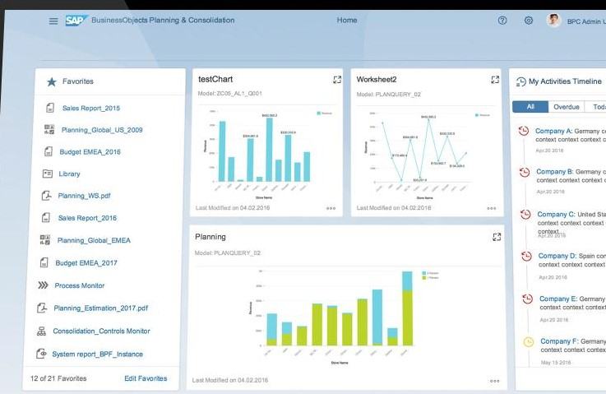

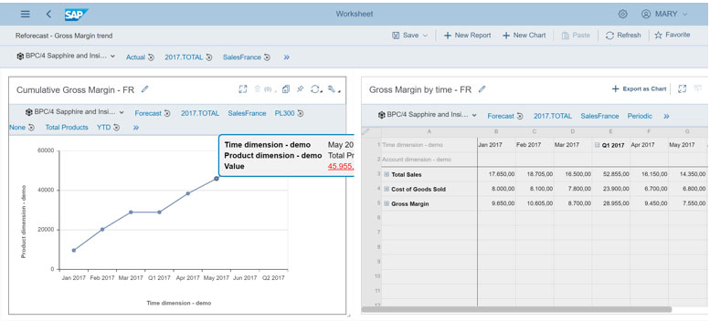

The Process Workflow
BPC allows the organization to set up tasks and maintenance for BPC clients. The software has two interfaces that are the web interface and the client application. The user selects the BPC software to start and selects the task to be completed. The browser window allows control of the software, application properties, and maintaining the software parameters. The user creates new dimensions which represent entities of business, for instance, the company category, codes, and accounts. Some dimensions are required in that they must exist in the software tool, while others are optional. These dimensions are then shared and available for the user in the applications.
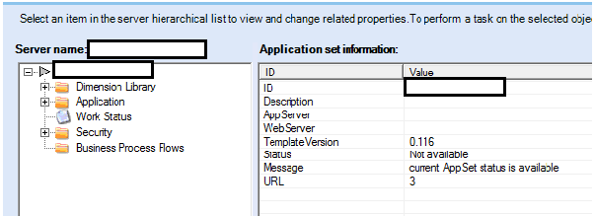
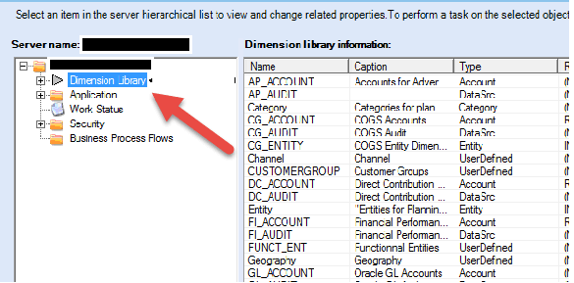

Process Analysis
SAP BPC supports the company's operational and financial planning requirements. Additionally, the tool manages the company's consolidation processes within a unified application. This unified and flexible solution allows SEC to focus more on strategic business and growth.

Recommendations
Saudi Electricity Company, over the years, has made a significant improvement in terms of business practices and strategies which have been a driving force behind the company's success. However, from human nature to technology to regulatory compliance and market variability, the prospects of risks and uncertainty exist nearly everywhere and in almost everything. Even so, is the ability to identify and effectively create a distinction between creating value and those that lead to success can only be achieved through a company's proactive approach. In today's business environment, being a risk-minded organization is critical as there is more at risk, and losses could be catastrophic. For this reason, organizations require board members and management to have more control over business processes, including operation, compliance, strategy, reporting, and understand risks that impact them. For the Saudi Electricity Company, an effective GRC program helps generate and preserve value as well and driving the company's performance improvements. Having effective GRC and SAP BPC programs should be the main focus of any organization, especially its management, as lack of support impedes progress. Saudi Electricity Company management should be at the frontline of establishing platforms that promote collaboration and visibility of financial, strategic, and operational plans and processes. Information on the company's business strategies, objectives, compliance, accountability, and practices should be presented to the stakeholders to inform their decision-making. Technology is a big part of today's business environment. SEC ought to fully integrate technology into its processes and practice to improve its operations and achieve its objectives.

Conclusion
Business processes are core assets to any organization. The organization to achieving its desired goal. This report has provided an analysis of two processes implemented by Saudi Electricity Company. This business process increases the company's flexibility in the changing business environment. SEC has well-organized management that ensures effective operational processes that have resulted in the company's business success. The implementation of various business process softwares, including SMART GRC and SAP BPC, enables the organization to execute the model, monitor and maximize its processes. Additionally, these software tools enhance the effectiveness of the company's processes. The technological integration of softwares into the business process has helped the company to address some of the significant challenges the organization has been facing. Optimization of these business processes can help Saudi Electricity Company improve its corporate management. The report covers various elements of the selected business process, including the technologies used in processes, the architecture, process workflow, and process analysis.

References
Ali, H. M. (2020). Corporate governance developments in the Saudi Arabia and Malaysia. UUM Journal of Legal Studies, 10(1), 185-214.
Alkedmn, E., & Eckler, P. (2019). Reputation management of companies during crises-A case study of the Saudi Electricity Company.
Company Information. Saudi Electricity Company. (2021). Retrieved 21 March 2021, from https://www.se.com.sa/en-us/pages/CompanyManagement.aspx.
Gerged, A. M., &Agwili, A. (2020). How corporate Governance affect firm value and profitability? Evidence from Saudi financial and non-financial listed firms. International Journal of Business Governance and Ethics, 14(2), 144-165.
Harper Ho, V. E. (2020). Board Duties: Monitoring, Risk Management, and Compliance. Risk Management, and Compliance (March 3, 2020). Research Handbook on Comparative Corporate Governance (Afra Afsharipour& Martin Gelter eds., Edward Elgar Publishing, Forthcoming).
Huang, Y., Li, W., Liang, Z., Xue, Y., & Wang, X. (2018). Efficient business process consolidation: combining topic features with structure matching. Soft Computing, 22(2), 645-657.
La Rosa, M., Dumas, M., Uba, R., &Dijkman, R. (2013). Business process model merging: An approach to business process consolidation. ACM Transactions on Software Engineering and Methodology (TOSEM), 22(2), 1-42.
McShane, M. (2018). Enterprise risk management: history and a design science proposal. The Journal of Risk Finance.
Miller, G. P. (2017). The law of Governance, risk management, and compliance. Wolters Kluwer Law & Business.
Murray, P. J., & Ward, R. J. (2018). Promoting Enterprise Risk Management (ERM) and Governance, Risk and Compliance (GRC) for Managing Cybersecurity Risks.
Raiborn, C., Butler, J. B., Martin, K., &Pizzini, M. (2017). The internal audit function: A prerequisite for Good Governance. Journal of Corporate Accounting & Finance, 28(2), 10-21.
Wiedenhoft, G. C., Luciano, E. M., &Magnagnagno, O. A. (2017). Information Technology Governance In Public Organizations: identifying mechanisms that meet its goals while respecting principles. JISTEM-Journal of Information Systems and Technology Management, 14(1), 69-87.

